
HYDROCARBON POLLUTION REMEDIATION PROJECT (HYPREP)
Project Coordination Office -Environmental Remediation Unit

Environmental Remediation of Hydrocarbon Impacted Sites in Ogoniland, Rivers State.
Phase 2 Soil and Groundwater Remediation Works on Medium Risk Sites (SMR Lots)

WEEKLY SITE ASSESSMENT ACTIVITY REPORT

Reporting Week: 9 Date:04/09/2023 to 08/09/2023
Duration of Contract (in Months): 24 Flag-Off Date: 27/04/2023 Mobilization Date: 11/07/2023
Expected End Date: 11/07/2025 Revised End Date: ….…/…..…/202…..
Duration on Site to Date (in Months -based on 22 Work Days per Month): 2Months/42 Days
1.0 SITE INFORMATION
LOT NUMBER |  | SMR LOT 36 | CONTRACTOR: |  |  |  |  |  | PHILCOM INTEGRATED LIMITED
SITE NAME (Name/Community) |  |  |  |  | F/S FLARE SITE AREA 2 – KWAWA COMMUNITY |  |  |  |  |  |  | UNEP Code: |  |  | qc_016 - 001
L. G. A | KHANA |  |  |  |  | SITE REFERENCE GPS COORDINATES (UTM, WGS84, ZONE 32N) |  |  |  |  |  | E:331632 |  |  | N: 509504
Area (m²) of impacted soil: in the Bill of Quantities (BoQ) |  |  |  | 18,800M² |  |  | Max depth of Impact (m) in the Bill of Quantities (BoQ) |  |  | 6.0m | Volume (m³) of Soil in the Bill of Quantities (BoQ) |  |  | 112,800m³
Maximum initial Groundwater TPH (µg/l) in the Bill of Quantities (BoQ) |  |  |  |  |  |  |  | 77,000ug/l |  | Maximum initial Soil TPH (mg/kg) in the Bill of Quantities (BoQ) |  |  | 8,800mg/kg

2.0 SITE INFRASTRUCTURE
S/No | Site Infrastructures | Quantity | Size {(LxBxH) = ….m²/m³}  -as applicable | Percentage Completion (%) | GPS Coordinates  (UTM, WGS84, Zone 32N) |  | Remarks / Working Condition
 |  |  |  |  | Easting | Northing | Remarks / Working Condition
1 | Site Offices | 1 | 27mx25mx3m | 100% | 331728 | 509657 | Completed
2 | Sewage pit | 1 | 2.4mx1.2mx2.5m | 100% | 331761 | 509670 | Completed
3 | Decontamination area | 1 | N/A |  |  |  | Not Yet
4 | Engineered Biocell | 1 | 50mx50mx1.5m | 20% | 331743 | 509422 | Building Ongoing
5 | Leachate sump | 1 | N/A |  |  |  | Not Yet
6 | Security Post | 1 | 3mx2mx2.7m | 100% | 331728 | 509657 | Completed
7 | Borehole/Stand | 1 | 0.6mx0.6mx15m | 100% | 331728 | 509657 | Completed
8 | Workers Sit Out | 1 | 4.9mx4.9mx3.5m | 100% | 331755 | 509652 | Completed
9 | Security Lights | 5 | 0.1mx0.1mx5m | 100% |  |  | Installed at the site office
10 | Liquid Waste Point | 1 | 3.7mx1.2mx0.3m | 100% | 331763 | 509643 | Completed
3.0 SITE HSE REPORT
3.1: Computation of Work Manhours
A | B | C | D | E
Total number of personnel on site | Number of days worked in the week | Number of days worked from inception to date | Week Manhours  (A x B x 8hrs) | Project to Date Manhours (A x C x 8hrs)
47 | 5 | 37 | 1,880 | 13,912
3.2: HSE Checks
S/N | Work Description | Number | Cumulative | Remarks
1 | Toolbox Meetings / Talks | 5 | 37 | Toolbox carried out daily
2 | Unsafe Acts / Unsafe Conditions / (UA/UC/) recorded | 3/0 | 11/2 | * Quarrel among workers * Horse Play  * Lifting heavy object wrongly
3 | Unsafe Acts / Unsafe Conditions (UA/UC/) Closed out | 3/0 | 11/2 | All UA/UC finally closeout
4 | Near miss | 0 | 4
5 | First Aid case | 1 | 2 | Bruise was handled by site Nurse
 | Medical Treatment Case | 0 | 1 | The worker was taken to retainership clinic in Bori where he had some rest.
6 | Environmental Incident | Nil | Nil
7 | Work disruption by on-site community staff | Nil | Nil
8 | Work disruption by off-site community intruders | Nil | Nil
9 | Work disruption due to breakdown of work equipment such as excavator, tiller, or bulldozer. | 1 | 9 | Equipment broke down rectified
10 | Lost hours due to equipment breakdown (Hrs) | 16 | 77 | Equipment finally in good condition
11 | Waste management practices on site – housekeeping issues | Nil | Nil
12 | Property/equipment damage | Nil | Nil
13 | Fire incident | Nil | Nil
14 | Monthly HSE meeting (s) | Nil | Nil
15 | HSE training | Nil | Nil
16 | No. of drills (Quarterly) | Nil | Nil
17 | Fatality | Nil | Nil
4.0 ASSESSMENT SAMPLING DATA
4.1: General Boreholes Information
ITEM | QUANTITY | ITEM | QUANTITY
No. of Borehole Installed | 10 | Total No. of Soil Samples Collected | 90 (80 Organic (30 Speciated and 50 Non-Speciated), 10 Inorganic
No. of Auger holes Drilled | 10 | Total No. of Groundwater samples collected | 20

4.2: Boreholes Sampling Information
S/N | Borehole Point ID | GPS Coordinates |  | Maximum Depth (mbgs) | Soil Sampling Intervals (mbgs) | Predominant Soil Lithology | No of soil samples collected per hole | Depth range of observed Impact  (mbgs) | Predominant physical observation |  | Depth to Ground-water  (mbgs) | Observed Impact on Ground-water (Y/N)
S/N | Borehole Point ID | Easting | Northing |  |  |  |  |  | Odour | Sheen | Depth to Ground-water  (mbgs) | Observed Impact on Ground-water (Y/N)
1
2
3
4
5
6
7
8
9
10
11

4.3: Auger holes Sampling Information
S/N | Auger hole Point ID | GPS Coordinates |  | Maximum Depth (mbgs) | Soil Sampling Intervals (mbgs) | Predominant Soil Lithology | No of soil samples collected per hole | Depth range of observed Impact  (mbgs) | Predominant physical observation
S/N | Auger hole Point ID | Easting | Northing |  |  |  |  |  | Odour | Sheen
1
2
3
4
5
6
7
8
9
10
11
12
13
14
15
16

CHRONOLOGY OF ACTIVITIES
S/NO | DATE | ACTIVITIES OF THE DAY | REMARK
1 | MONDAY  04th September, 2023 | - Toolbox Meeting  - Bio-Cell Preparation  - General Housekeeping | find attached photos
2 | TUESDAY  05th September, 2023 | - Toolbox Meeting  - Sand Bagging by community workers  - Slopping and Gradient of the Bio-Cell  - General Housekeeping | find attached photos
3 | WEDNESDAY  06th September, 2023 | - Toolbox meeting  - Sewing of Sand Bags  - Loading of Sand bags to Bio-Cell Area  - General Housekeeping | find attached photos
4 | THURSDAY  07th September, 2023 | - Toolbox meeting  - Sewing of Sand Bags  - Stagging of Sand bags in Bio-Cell Area  - General Housekeeping | find attached photos
5 | FRIDAY  08th September. 2023 | - Toolbox meeting  - Sewing of Sand Bags  - Loading of Sand bags to Bio-Cell Area  - General Housekeeping | find attached photos

Mr. Justice Barima
Project Manager

SITE PHOTOS
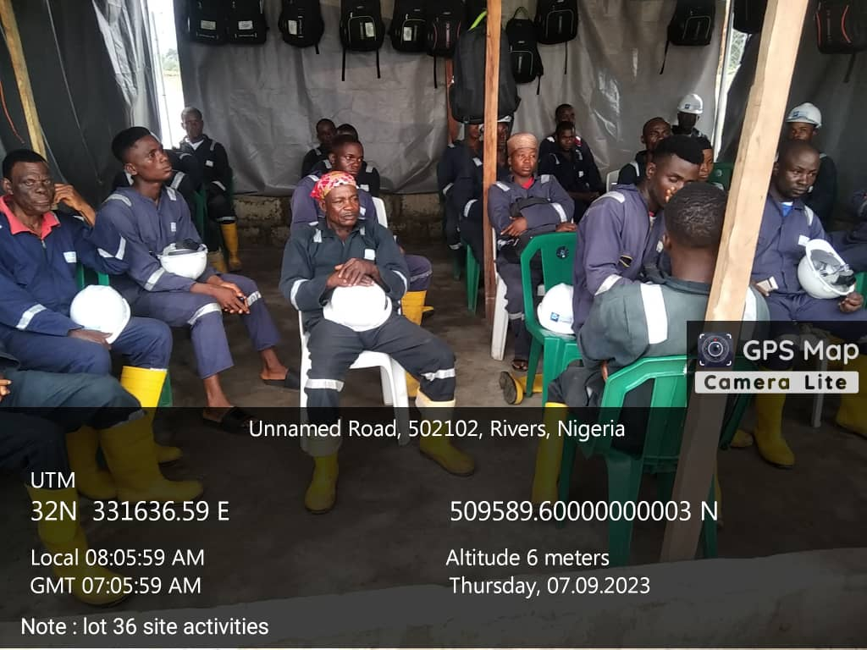
Plate 1: Toolbox Meeting
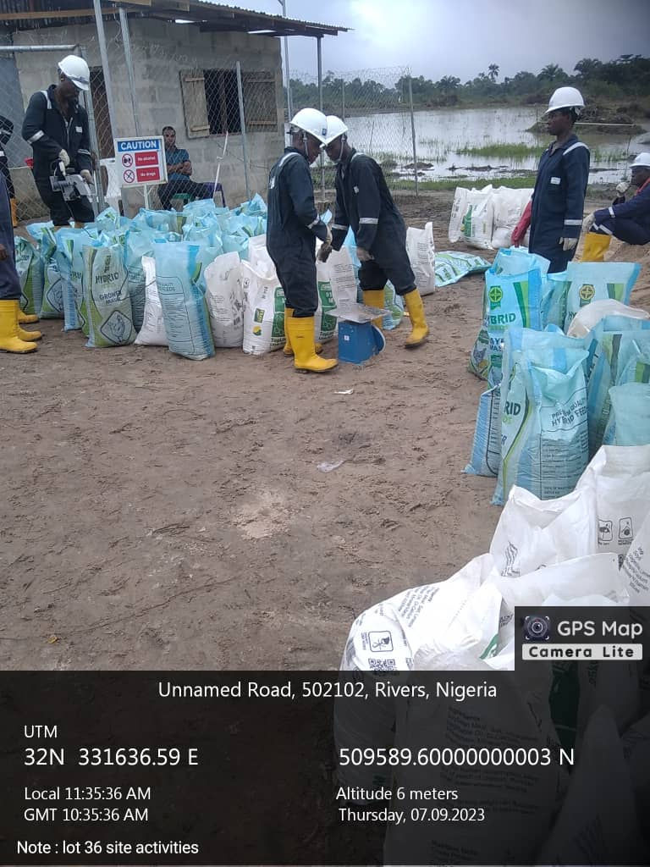
Plate 2: Sandbagging and Sewing Ongoing

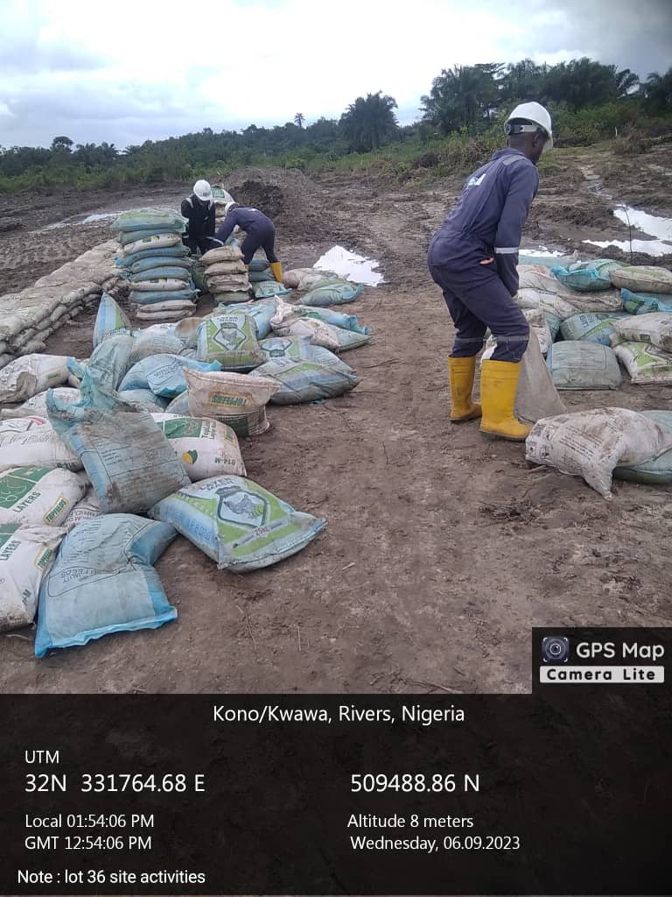
Plate 3: Movement of Sandbags to Biocell Area by Community Workers
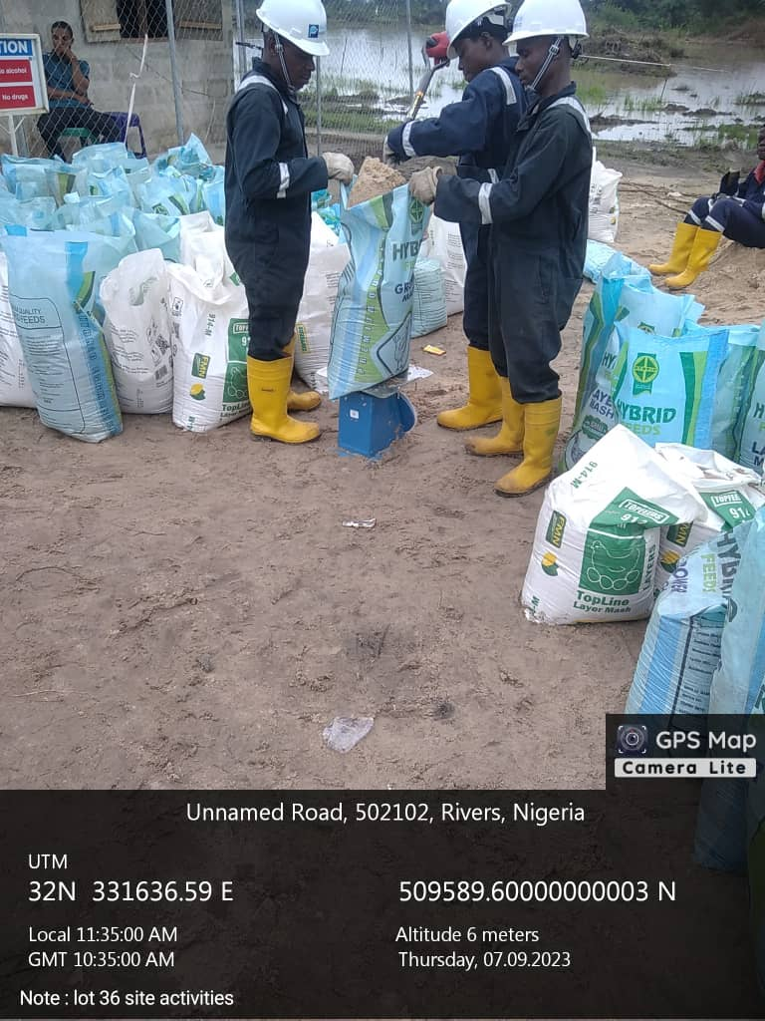
Plate 4: Weighing of Sand Bags Ongoing

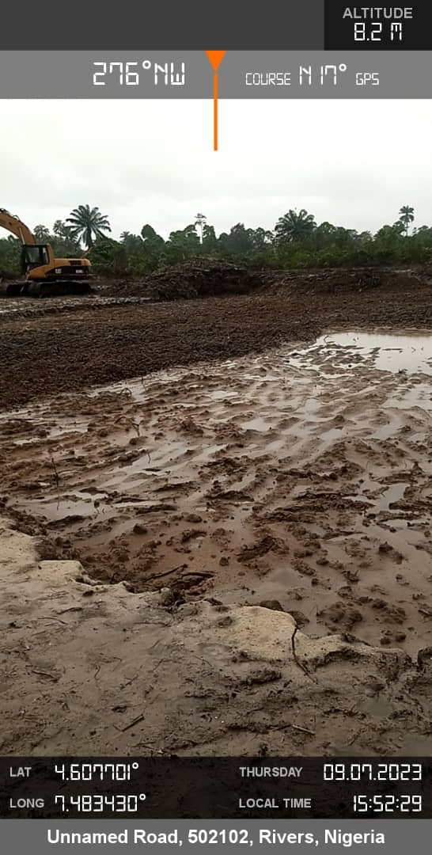
Plate 5: Levelling of Biocell
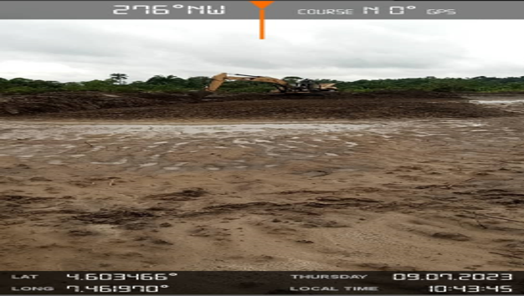

Plate 6: Levelling of Biocell

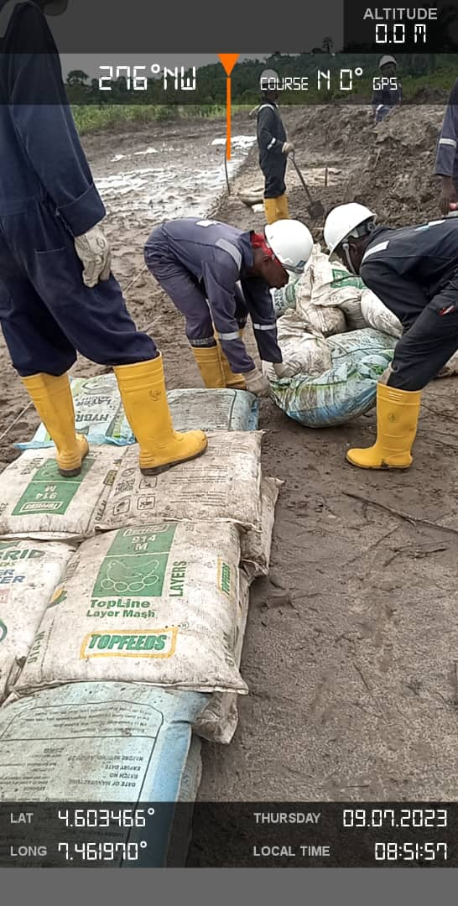
Plate 7: Staging of Sand Bags

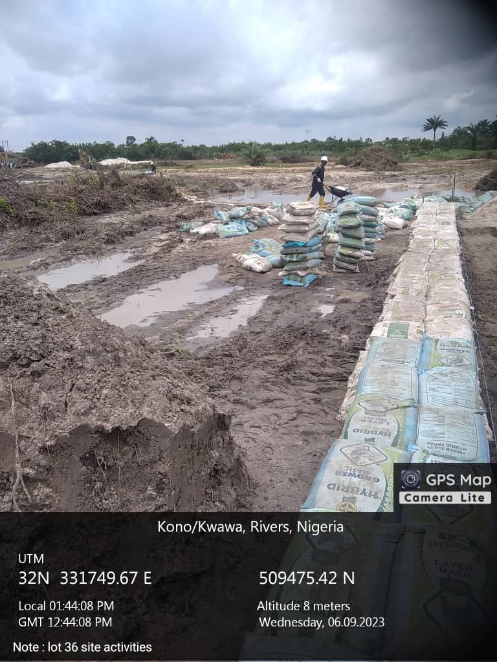
Plate 7: Staged Sand Bags in Bio-Cell Area

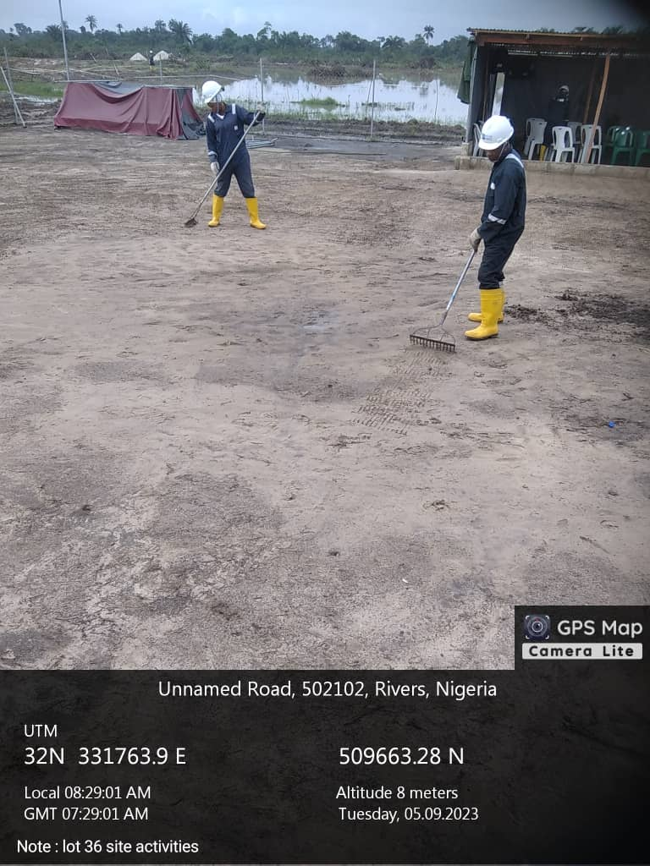
Plate 8: General House Keeping of the Office Area

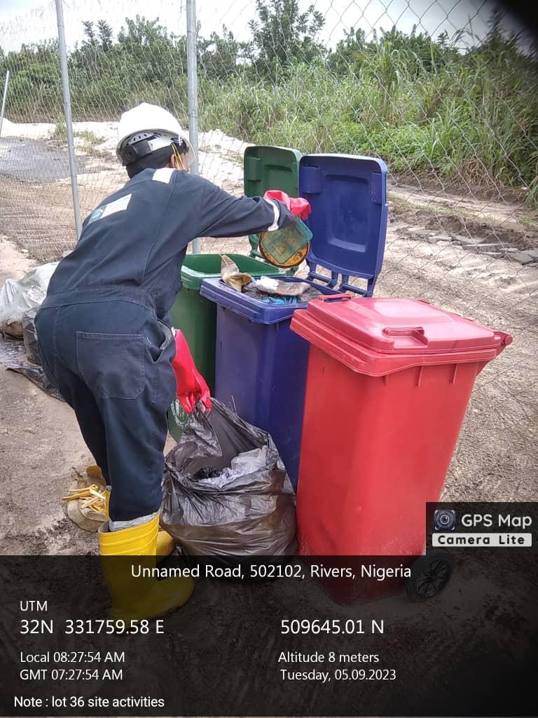
Plate 9: House Keeping/Solid Waste Mgt.

